The Localization of the SDGs and the 2030 Agenda
Survey on the role of
Local and Regional Governments’ and Associations

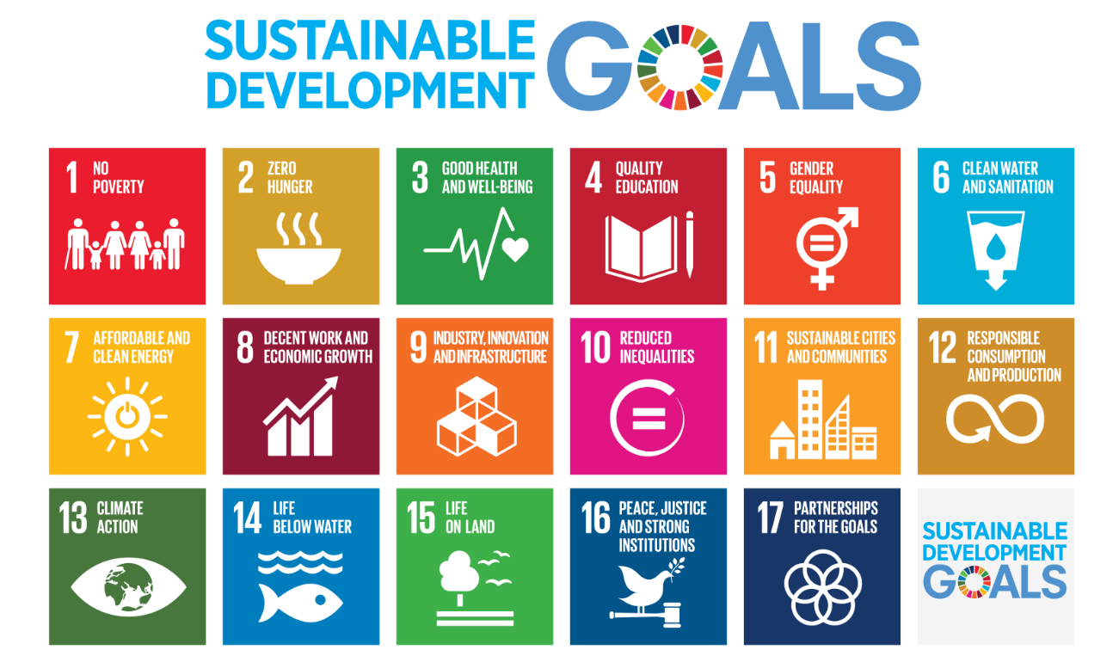
Name of your Organization (municipality, region, other local government, national association of local governments, etc.):

Executive Director (if information is available):

Actual respondent to the questionnaire:

Position within the Organization:

E-mail address:

Telephone and/or Skype address:

Please send back this survey – preferably by April 15, 2019 – to: gold@uclg.org & nathalie.noupadja@ccre-cemr.org

INTRODUCTION
Several major documents have been adopted over the past few years in the framework of the United nations to lead global development policy. The 2030 Agenda, the New Urban Agenda, the Paris Climate Agreements and the Sendai Disaster Risk Reduction Framework are all parts of this international consensus.
This Survey specifically refers to knowledge, awareness and implementation of the 2030 Agenda and its 17 Sustainable Development Goals (SDGs) at the local level. The Survey aims to assist UCLG and the Global Taskforce of Local and Regional Governments in the realization of the report on local and regional governments’ role in the localization of the SDGs: this information will be shared at the forthcoming High-Level Political Forum (HLPF) – i.e. the United Nations central platform for follow-up and review of the 2030 Agenda for Sustainable Development – in July 2019, in New York.
At the same time, the Survey is designed to assist local and regional governments and their associations and networks to share knowledge, collect information, develop their own reporting methods and information, as well as contribute to national debates and process of monitoring of the SDGs and the other agendas.
Many SDGs cover activities that are part of the daily work of local and regional governments (education, health, water and sanitation, waste management, public transport, adequate housing for all, gender equality, urban planning, disaster risk prevention, sustainable environment, climate change mitigation and adaptation, among many others). While they may even be unaware of it, many local governments have in fact been taking action to implement the SDGs for years.
With this year’s Forum in sight, the Survey is especially important for the local governments of those 51 countries that have already committed to submit their national reviews to the HLPF in 2019:
- Africa (18): Algeria, Burkina Faso, Cameroon, Central African Republic, Chad, Côte d’Ivoire, Eritrea, eSwatini, Ghana, Lesotho, Mauritania, Mauritius, Republic of the Congo, Rwanda, Sierra Leone, South Africa, Tanzania, Tunisia
- Asia-Pacific (11): Cambodia, Fiji, Indonesia, Nauru, New Zealand, Pakistan, Palau, Philippines, Timor-Leste, Tonga, Vanuatu
- Eurasia (4): Azerbaijan, Kazakhstan, Mongolia, Turkmenistan
- Europe (7): Bosnia and Herzegovina, Croatia, France, Iceland, Liechtenstein, Serbia, United Kingdom
- Latin America (5): Brazil, Chile, El Salvador, Guatemala, Guyana
- MEWA (5): Iraq, Kuwait, Oman, Turkey (Israel is reporting to the UN but is not part of the UCLG MEWA section)
- North America (1): Saint Lucia
This list, alongside that of the 102 countries that have already reported from 2016 to 2018, is available on the HLPF webpage: https://sustainabledevelopment.un.org/hlpf.
The Survey includes 25 compulsory closed questions and 4 open-question boxes divided in four sections:
- Awareness of the Global Agendas (4 questions)
- National context for SDG implementation and monitoring (12 questions)
- Actions of local and regional governments and their associations to support SDG implementation and monitoring processes (9 questions)
- From political commitment to practical application of the SDGs (6 questions)
Instructions are provided for each question whenever necessary. However, should you need any support when answering the Survey, please contact our department at UCLG at these addresses: gold @uclg.org, and nathalie.noupadja@ccre-cemr.org
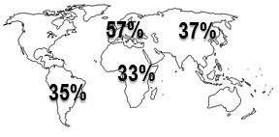
Responses for previous Surveys are collected and analysed in the series of local and regional governments’ reports, Towards the localization of the SDGs, presented to UN Member States at the 2017 and 2018 High Level Political Forums.
57%
The key findings of the Surveys show that in 39 countries (out of 99 analysed in total) local and regional governments have been actively involved in national mechanisms for coordination and follow-up on SDG implementation. Local and regional governments’ involvement, however, has hardly been homogenous, and still depends significantly on national context.

- Awareness of the global agendas
- Are you familiar with and/or involved in the implementation of the SDGs (2030 Agenda)?
⃝ I am not familiar with the SDGs
⃝ I know the SDGs exist, but am unfamiliar with their details
⃝ I use the SDGs as a reference, but they are not high in our work priorities
⃝ I align my work priorities with the SDGs
- Are you familiar with and/or involved in the implementation of the other global (i.e. New Urban Agenda, Paris Climate Agreements, Sendai Framework, Global Compact for Migration)?
⃝ I am not familiar with any of the other global
⃝ I know they exist, but am not sure how they relate to my work
⃝ I refer to some of these Agendas in my political work as a reference
⃝ I have integrated the Agendas in my advocacy and daily work
- How familiar with and/or involved in the implementation of the SDGs would you say your organization is?
⃝ Very few individuals in the organization are familiar with the SDGs
⃝ Many have heard about the SDGs, but are not aware about their relevance
⃝ The majority of our staff is aware and makes reference to the SDGs, but it is not high in our work priorities
⃝ The SDGs are well known in our organization and used as an important reference in our strategies
- The coordination of SDG-related work is performed by:
⃝ International department
⃝ Environment department
⃝ Top-management service
⃝ Interdepartmental SDG team
⃝ Several or all departments deal with SDGs
⃝ Other: ________________
- National context for SDG implementation and monitoring
II.A: What is your national government doing for the implementation of the SDGs?
- Is there a national framework or strategy to implement the SDGs and the other global agendas in your country?
Yes ⃝ No ⃝ (if not, go to question 6)
  - If yes, does the framework/strategy mention the need to support local and regional governments for implementation at local levels?
Yes ⃝ No ⃝

- Has your organization been consulted by your central/federal government for the design, implementation or monitoring of these national strategies?
Yes ⃝ No ⃝
II.B: Reporting to the High-Level Political Forum and the involvement of local and regional governments
- Is your country reporting to the UN HLPF in 2019?
Yes ⃝ No ⃝ (if not, go to question 8)
  - If yes, has your organization being informed about and involved in the national reporting process (i.e., Voluntary National Reviews)?
Yes ⃝ (go to question 8.1) No ⃝
- If your country reported to the HLPF in previous years (2016-2018), was your organization invited to contribute?
Yes ⃝ No ⃝ (if not, go to question 9)
  - If yes, was your organization invited to contribute to the report:
[you can pick more than one option]
⃝ In the reporting unit appointed by the national government as well as in the drafting process (strong involvement)
⃝ By presenting your own contribution to the report (e.g. about what local and regional governments are doing to implement the SDGs, etc.) (strong involvement)
⃝ By attending bilateral meetings (e.g., between your organization/elected officials and the reporting unit) (high/moderate involvement)
⃝ By participating in national/regional conferences or workshops to debate the report (moderate involvement)
⃝ By answering a survey or questionnaire (moderate involvement)
⃝ By participating in occasional informative workshops, with limited room to contribute to the actual report (weak involvement)
⃝ By being invited to the presentation of the VNR once this was finalized (weak involvement)
⃝ Other: ________________
- If your country does not report to the HLPF in 2019, is your government preparing any annual progress report on the implementation of the SDGs for national purposes?
Yes ⃝ No ⃝ (if not, go to question 10)
  - If yes, has your organization been invited to contribute to such report?
Yes ⃝ No ⃝

Box 1. General comments to section “National context for SDG implementation and monitoring”
Do you consider that your participation in the reporting process was adequate? Were your contributions taken into consideration in the Voluntary National Review or in the national report?
[use all the space you may need]

II.C: Involvement of local and regional governments in national coordination or follow-up mechanisms on the SDGs, and their impact on institutional context
In most countries, national governments have either created specific institutional mechanisms (e.g., high-level commissions, inter-ministerial/interagency committees, etc.) or strengthened existing ones (often including national councils for sustainable development or national planning institutions) to improve coordination and follow-up for the implementation of the SDGs.
Generally, these mechanisms are not the units dedicated to the preparation of the reports to the HLPF.
In some cases, local and regional governments have been invited – to a varying degree – to participate in these institutional mechanisms (e.g., full or consultative status, participation in technical commissions, etc.).
- Has your national government put in place any institutional mechanism to ensure coordination on and follow-up of SDG implementation?
Yes ⃝ No ⃝ (if not, go to question 11)
  - If yes, have your association or any representative of local and regional governments been invited or associated to such mechanism?
Yes ⃝ No ⃝

Box 2. Please provide more information – if available – on coordination mechanisms, the role of local and regional governments and the changes they have driven in multi-level dialogue. Whenever possible, please provide examples on policy changes, reforms and/or initiatives proposed to support the role of local and regional governments in SDG localization.
[use all the space you may need]

- Have coordination mechanisms and SDG implementation strategies had any impact on cross-level governance relationships and national policies towards local and regional governments?
Yes ⃝ No ⃝
- Initiatives by LRGs and their associations to support SDG implementation and monitoring
III.A: Awareness-raising, commitments and actions developed by local and regional governments’ and associations
- Has your organization adopted specific policy documents (e.g., statements, papers, declarations, roadmaps, etc.) on the implementation of the SDGs or the other global agendas?
Yes ⃝ No ⃝
- Has your organization promoted activities (e.g., campaigns, conferences, communication, trainings, etc.) to support SDG implementation and dissemination among local governments?
Yes ⃝ No ⃝

Box 3. Please provide a brief description of your initiatives or other activities over the past year designed to raise awareness and involve local and regional governments, as well as inhabitants, in SDG implementation processes (please add reference to any relevant web resources, if available).
[use all the space you may need]

- Do you know about any other initiatives in your country to inform or support local governments about the SDGs and other global agendas?
Yes ⃝ No ⃝ (if not, go to question 15)
  - If yes, have these initiatives been promoted by:
⃝ The national government
⃝ International institutions or donors
⃝ International local and regional governments’ institution or networks
⃝ NGOs or foundations
⃝ Other: ________________

III.B: Monitoring and reporting on the implementation of the SDGs at local level
- Do you know any initiatives of local and regional governments to monitor and report on the implementation of the SDGs?
Yes ⃝ No ⃝
- Is there any initiative in your country to develop local indicators to monitor the SDGs and/or disaggregate data collection?
Yes ⃝ No ⃝
- Is your organization interested to work on specific indicators and/or initiatives to monitor the implementation of the SDGs at local level?
Yes ⃝ No ⃝
III.C: Moving towards the implementation of the SDGs
- Is there any initiative or project being developed to support either the alignment of local development plans with the SDGs or the local implementation of the SDGs?
Yes ⃝ No ⃝ (If yes, please describe the initiative in Box 4 below)
- What do you think are the main challenges that local and regional governments face in working towards the achievement of the SDGs and the other global agendas?
Please select no more than 5 options and rank them by relevance from 1 (most important) to 5 (least important):

⃝ Limited access to information
⃝ Limited support from national governments
⃝ Limited coordination across levels of governments
⃝ Limited local interest and/or awareness (e.g. local governments don’t understand the SDGs or find not relevant or they perceive the SDGs as a new burden, not adapted to the local priorities)
⃝ Inadequate human resources or weak capacities
⃝ Insufficient financial resources
⃝Need for legal and institutional reforms to empower local and regional governments
⃝ Other: ________________

Box 4. Please mention some examples of local or regional governments that are developing initiatives to align local development plans with the SDGs, for monitoring and reporting, or that have developed a set of local or adapted indicators to monitor the SDGs at local level.
[use all the space you may need]

- From political to practical commitment
- How does your organization deal with the interlinkages and transversality of the SDGs?

⃝ Inter-departmental working methods have been set up
⃝ Development of joint activities with external stakeholders (CSOs, universities, think tanks, etc.)
⃝ The association has chosen to focus the work on one/few SDG(s)
⃝ No strategy has been put in place
- How does your organization deal with the internal and external dimension of the SDGs?

⃝ Development of international/city-to-city partnerships
⃝ Involvement in European/international networks and fora (participation to international events, campaigns, etc.)
⃝ Collaboration with international officers
⃝ Collaboration with colleagues from other departments on thematic issues
⃝ Strengthening lobbying activities toward national governments
⃝ No strategy has been put in place
⃝ I am not sure/I do not know
- To what extent would you agree the SDG framework has helped your organization develop its partnerships?

⃝ It helps developing the International partnerships
⃝ It strengthens working with European and international networks
⃝ It allows working with external stakeholders (CSOs, universities, think tanks, etc.)
⃝ It strengthens the collaboration with the national government
⃝ It does not influence my organization’s partnerships
⃝ Other: _________________
- So far, your organization has been working with the SDG framework to:
(please select as many options you need)

Objectives/  Recipients | To raise awareness | To develop action plan framework on sustainability | To give training | To boost exchanges | To collect data and monitor strategies | To improve advocacy to other tiers of government | To report
Citizens
Members
(if you are from an association)
National government
Political leadership - presidency
European networks
EU institutions
International networks
With non-European local governments
- As association or local government, are you setting-up dedicated activities to support your non-European partners in their efforts to localise the SDGs?

Yes ⃝ No ⃝
- If relevant, how would you assess the knowledge of your non-European partner about the SDGs?
⃝ They are not familiar with the SDGs
⃝ They know the SDGs exist, but are unfamiliar with their details
⃝ They use the SDGs as a reference, but they are not high in their work priorities
⃝ They align their work priorities with the SDGs

See next page: please provide – if available – a list of local and regional governments in your country that are taking actions to support SDG implementation, in particular related to the SDG 11 on sustainable cities and communities and the Goals that will be assessed this year at the HLPF (SDG 4 on education, SDG 8 on decent work, SDG 10 on reduced inequalities, SDG 13 on climate action and SDG 16 on peace, justice and effective, accountable and inclusive institutions at all levels). Please provide any relevant information available on these initiatives, and in particular any relevant sources or references.

Thank you!
Please send back this survey to gold@uclg.org
and nathalie.noupadja@ccre-cemr.org,
preferably by April 15, 2019.

Name of local or regional government/  association of local and regional governments | BRIEFLY DESCRIBE THE POLICIES AND/OR PROJECTS  (one or two sentences) | SOURCES  Whenever possible, mention any internet resources or references – either relevant or providing direct access to information

